Customer Churn EDA Report
---------------------------------------------------------------------

Overview:

This report presents an exploratory data analysis (EDA) of the customer churn dataset to uncover key trends, patterns, and insights that may influence customer retention. The dataset contains demographic, service, and financial information about customers, along with churn labels.

Key Dataset Features:

Demographic: Age, Gender, Region

Service: Plan Type, Service Usage, Resolution Status

Financial: Amount Spent, Subscription Tenure

Target Variable: ChurnStatus (0 = Retained, 1 = Churned)

Key Insights:

Churn Distribution:-

The dataset shows a class imbalance, with a smaller proportion of customers marked as churned.

This highlights the need for resampling or using metrics like F1 score during model evaluation.

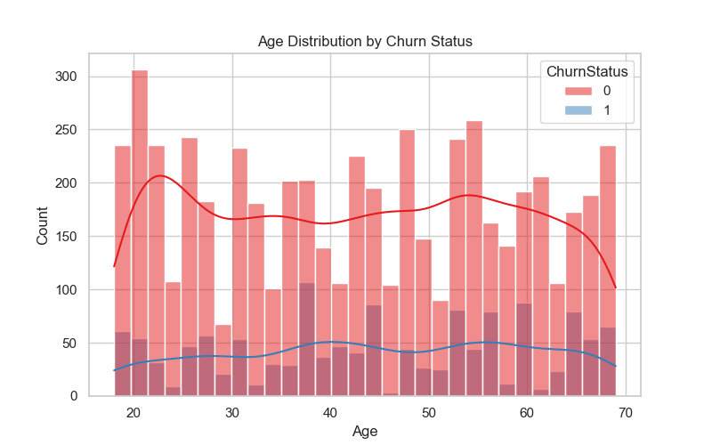

Amount Spent vs Churn:-
On average, customers who have churned spent significantly less.
This suggests a correlation between financial value and customer loyalty.

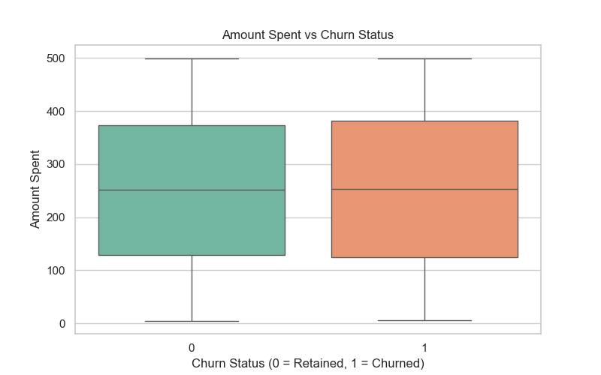

Tenure vs Churn:-

Long-tenured customers are less likely to churn.

Tenure is a strong predictor of retention.

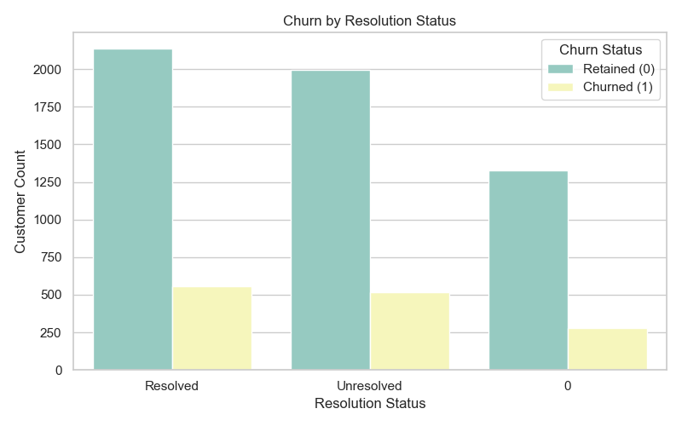

Correlation Heatmap:-

Positive correlation between tenure and total amount spent.

Negative correlation between churn and both tenure and amount spent.

Resolution status is weakly to moderately correlated with churn.
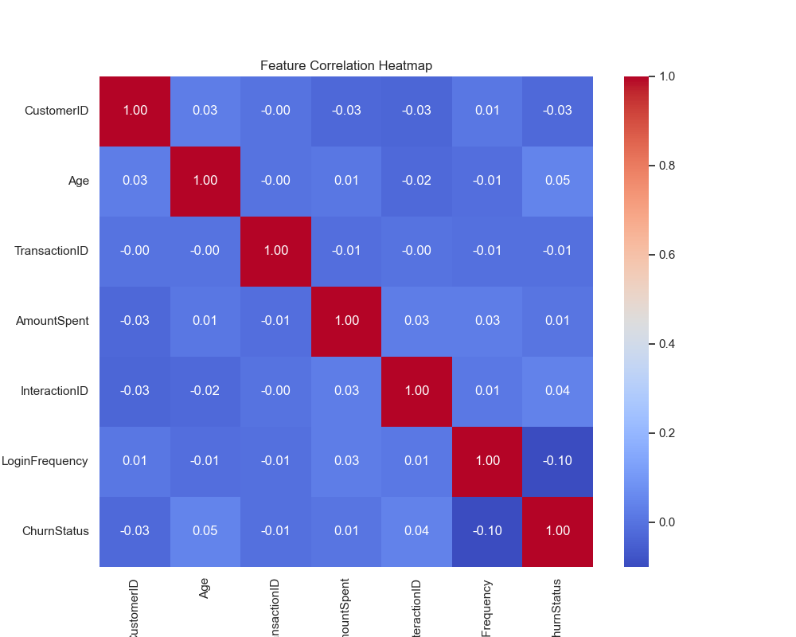

Resolution Status vs Churn:-

Customers with unresolved or pending issue statuses are more likely to churn.

Improving customer service could reduce churn.
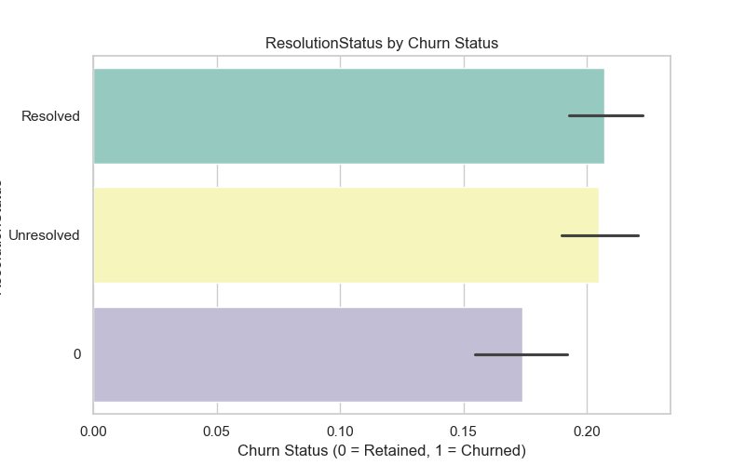

Conclusion:

The EDA reveals that financial engagement (e.g., amount spent), service satisfaction (e.g., resolution status), and loyalty indicators (e.g., tenure) are strong predictors of customer churn. These features are valuable inputs for machine learning models and should be prioritized during feature selection.

